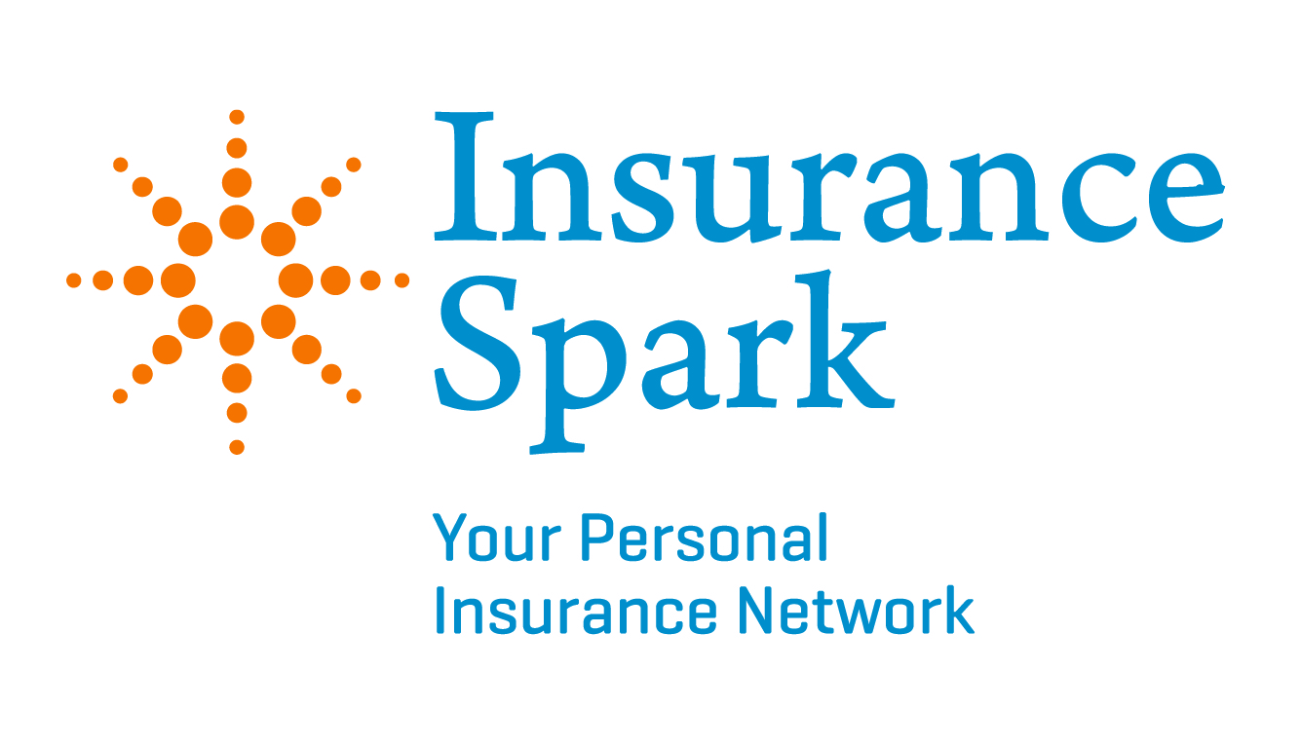
Contact: Sonya Thesing, Director of Operations
Phone: 614-309-6924
Email: sonya@insurancespark.com
September 26, 2013
FOR IMMEDIATE RELEASE

Local Company Ready for Affordable Care Act Open Enrollment

(DUBLIN, OHIO) To meet the challenges of the changing healthcare landscape, Strategic Business Services (SBS) has created Insurance Spark to market and sell individual health insurance. SBS is a full-service employee benefits agency founded by Adam Minton, James M. Vaughan, Tom Paplaczyk and T. Cary Jennings in 2005. Since the company’s inception, SBS includes over 40 agents in central Ohio and administers over 5,000 small business employee benefit plans.

“The implementation of the Patient Protection and Affordable Care Act (PPACA) creates confusion in much of the health insurance industry,” said Minton. “An incredibly high number of people will be making insurance decisions for themselves within the next six months, and while the classification of plans is meant to be simple, the truth is that the terms can be very confusing and intimidating. Insurance Spark is strategically designed to simplify the insurance purchase process and to help consumers navigate open enrollment. Many consumers are not aware of the factors that determine what insurance products they can and should buy, or how to cover gaps in their existing plans. In addition, some consumers may be eligible for government subsidies and not even know it. That’s where we come in.”

Insurance Spark has leveraged strong long-time relationships with Ohio’s major insurance carriers to gain access to informational resources. Planning for Insurance Spark began in 2010 to prepare for changes brought by PPACA. Development for the new division began last year as the partners recognized the need for a new business model in the post-healthcare reform market. Required licenses and certifications to sell exchange products are evolving as agencies are suddenly working with individual consumers, rather than selling to groups. SBS has been selling to individuals and small groups since SBS’s inception.

The PPACA open enrollment period begins October 1 and Insurance Spark is uniquely positioned to meet the expected increase in individuals seeking to buy health coverage and to offer a level of service that has never been experienced in the insurance industry. A call center is being fully staffed with licensed agents and the new Insurance Spark website is now live.

Insurancespark.com will feature a subsidy calculator to help shoppers determine the government assistance they can expect. Insurance Spark will carry government-approved health plans, also known as exchange plans or HIX plans, and will also carry off-exchange plans with major carriers in the private market. In addition to health insurance products, Insurance Spark will offer a full range of insurance products including dental, life, disability, accident insurance and more. Live web chats with licensed agents and access to multiple carriers will assist shoppers in making their coverage decision.

“We recognize that for many individuals, open enrollment will be the first time they have purchased health coverage,” said Sonya Lin Thesing, Director of Operations. “The agents at Insurance Spark are trained to guide clients through the process with education and advice.”

About Insurance Spark
The four partners of Insurance Spark; a division of Strategic Business Services, have been actively selling group and individual health insurance since the early 1990’s. Founded in 2005, Strategic Business Services merges our combined experience of over 100 years, joining forces with experts in other fields of insurance and utilizing their existing relationships. The result has been an alliance with over 40 successful independent insurance agents. Strategic Business Services sells and services all products an employer needs for their employees’ benefit plan and we have a strong focus on small group health insurance.

Insurance Spark was created to simplify and personalize the confusion of healthcare reform. We have streamlined our operations to serve individuals who will be buying healthcare for themselves for the first time.
#####

